技术报告---Wi-Fi P2P

文献[1]第7章“深入理解Wi-Fi P2P”读书笔记。

在Wi-Fi技术体系中，除了802.11定义的标准规范外，Wi-Fi联盟（Wi-Fi Alliance）还推出了两项重要的技术规范，分别是WSC（Wi-Fi Simple Configuration）和P2P（Wi-Fi Peer-to-Peer）。P2P技术使得多个Wi-Fi设备在没有AP的情况下也能构成一个网络（P2P Network，也称为P2P Group）并相互通信。

P2P Device Address 唯一，作用等同于MAC。

P2P Interface Address 可以有多个，用于加入Group后，和Group中成员交互使用。

Group Formation包括两个阶段，依次是GO Negotiation和Provisioning。Provision Discovery流程不属于Group Formation，PD作用于Group Formation之前，以提前邀请用户输入WSC安全配置所需的信息（例如PIN码）。PD阶段获取的安全信息直接用于后续Group Formation（GO和Provisioning两阶段时间限制为15秒）的Provisioning，避免在Provisioning阶段让用户输入安全配置信息。

## 参考资料

[1]邓凡平. 深入理解Android Wi-Fi、NFC和GPS卷. 北京：机械工业出版社，2014

1. 2015年5月31日16:22:19

关于Android中Wi-Fi Direct的实现细节的一些初步分析结果笔记。

1. 2015年6月4日14:48:27

添加有关Wi-Fi源码的各个文件的功能简介和简要的逻辑运行顺序。

1. 2015年6月7日20:34:14

删除4.WifiP2pSettings源码分析部分内容

1. 添加在Android上使用Wi-Fi Direct的取消用户认证过程，实现自动化认证的结果（实现取消用户参与的自动化认证方案的研究结果）；

技术报告---Programming of Android Based WSC

1. Android系统中有关WSC(Wi-Fi Simple Configuration)的代码内容

图1-1 设置WSC相关的接口

1. 真实设备测试结果

参考资料：[Google--android-platform ›Wi-Fi Direct questions](https://groups.google.com/forum/#!topic/android-platform/hN5WfXRzXpI)

* 1. PBC模式

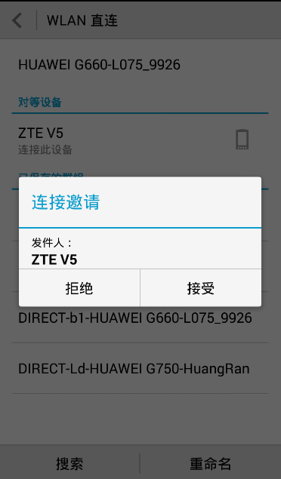

图1-2 接收连接邀请设备提示框

config.wps.setup = WpsInfo.PBC;

Asks if MAC address can connect; On OK, connect completes successfully

On connect, asks user to validate MAC address on remote device. Entering OK works.

Summary: Simplest configuration method but confusing since user has no notion of MAC addresses and whether something is valid or not. Also not clear how one can avoid a popup requesting the user to validate a confusing MAC address especially if the application has other (better) ways of discovery/auth.

* 1. DISPLAY模式

2pconfig.wps.setup = WpsInfo.DISPLAY;

p2pconfig.wps.pin = "0000";

On connect, PIN is displayed on local device and requests user to enter same PIN on remote device; once PIN is entered, connect completes successfully.

Summary: Works but very cumbersome to have a popup on local device and to enter an 8 digit PIN. Is there a programmatic way to **set/share PIN info**?

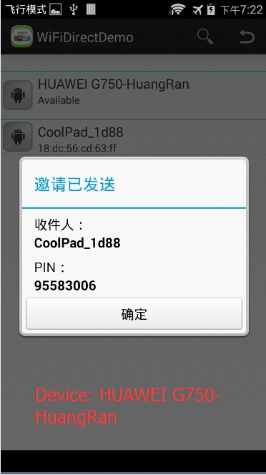 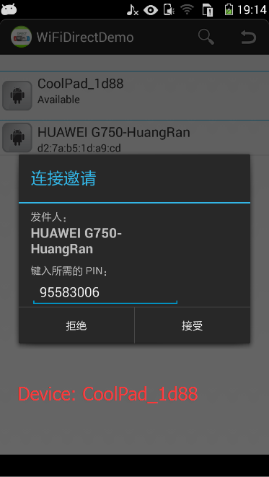

图1-3 发起邀请和接收连接设备提示框

* 1. LABEL模式

p2pconfig.wps.setup = WpsInfo.LABEL;

p2pconfig.wps.pin = "0000";

On connect, asks user for PIN on remote device. Entering 0000 on remote device works. However if wrong PIN is entered, can't reconnect again at all!! On failed device, peer discovery stops as well.

Summary: Works but not clear if there is soft way to **pre-program the PIN** so the user does not have to manually enter it since the pop-up is annoying for co-operating applications and esp since service discovery does not work.

设备A发起连接，仅显示已发送邀请，但是流程似乎处于阻塞状态（正在连接中……），无法成功建立连接，并且A再也无法进行扫描或重新发起连接的操作。

根据WifiP2pService.java源码，似乎没有对LABEL模式的支持与处理代码，即暂时不支持该模式。

* 1. KEYPAD

p2pconfig.wps.setup=WpsInfo.KEYPAD (don't specify p2pconfig.wps.pin)

It displays a dynamically generated key on the device from which we are trying to connect to be entered on the other device.

设备A发起连接，对端设备B显示PIN码并向A发出邀请，设备A无任何反应动作，无法成功建立连接。

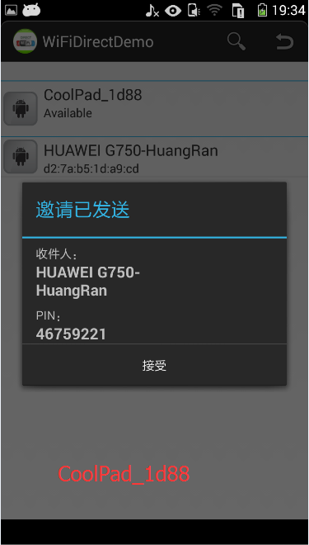

p2pconfig.wps.setup = WpsInfo.KEYPAD;

p2pconfig.wps.pin = "0000";

On connect, asks user for PIN on remote device. Not clear what should be entered and how PIN should be configured on local device. Entering 0000 on remote device does not work.

Summary: **Not clear how PIN should be configured and what should be entered on remote device**?

* 1. INVALID模式

无法正常工作。

Other Information：

The framework is unstable and clearly not product ready: device stops discovering neighbors, Wi-Fi direct goes off and cannot be turned on again (reboot required), Wi-Fi direct hangs in the ‘connecting’ state.

 For this case, the local device hangs in the connecting state and nothing happens at the remote device (no pop-up dialog - nothing).

When two devices try to connect through Wi Fi, we get a popup with Accept/Decline. Is it possible to remove this pop up so that the 2 devices connect automatically?

Did you find a way to connect devices without the pop up? I need to connect two devices without user interaction and verify the passkey.

I'm looking for a way to connect devices without a popup.

1. Automatic authentication for Android Wi-Fi Direct
   1. 参考资料：[Automatic authentication for Android WiFi Direct](http://stackoverflow.com/questions/9206043/automatic-authentication-for-android-wifi-direct)

It seems that automation of authentication dialogs is not possible, and this makes p2p routing impossible as well. Right now, the WpsInfo class (which is used in the WifiP2pConfig class that gets passed into the WifiP2pManager's connect() function during peer connection) only displays authentication dialogs in four ways: DISPLAY / KEYPAD / LABEL / PBC. I believe that PBC (push button config ) is the default and is what you refer to. The other three options require the user to input a type of pin, making them even more unusable for automated connections. Maybe if we were to find the type of this authentication dialog class, we could automate the clicking of the 'ok' button?

I wish a new option could be added that would give the application the ability to authenticate a connection, rather than the user. This user based authentication looks like its been carried over from the bluetooth api, and severely limits the usefulness of wifi direct.

* 1. 实现方案构想

3.2.1针对PBC模式

找到PBC模式下的Authentication Dialog运行位置，然后自动实现“OK”按键选择的回复信息。

3.2.2 针对PIN相关模式

1）预置相同的PIN嘛；2）Device A与Device B分享A随机生成的PIN码，可能需要其它的通信手段（如Bluetooth）辅助交互安全配置信息。

1. 实现取消用户参与的自动化认证方案的研究结果

通过分析Android上Wi-Fi Direct的实现代码，可以得到如下几个结论：

1）无法取消WSC安全认证机制；

2）在Wi-Fi P2P实现模块中定义了WSC存在四种模式PBC、DISPLAY、LABEL、KEYPAD，但是Android4.4.3源码仅支持三种模式PBC、DISPLAY、KEYPAD，并且实际测试时只有PBC和DISPLAY两种模式可以正常工作；

3）针对PBC和DISPLAY两种模式，可以取消弹出提示框，避免用户的参与，但是无法仅在应用层实现；必须要改动框架层的代码（改动量很小），在WifiP2pService.java文件中注释掉对应的弹出框代码并直接进行PBC的连接即可；但是该模块属于系统级的Service服务，暂时无法通过替换service实现，因此需要重新编译framework层代码并替换设备上的原有框架层jar包；

4）上述方案可以实现，不过存在一些问题：<1>针对不同的设备系统可能需要分别编译对应版本的framework.jar包；<2>一旦实施框架层包替换，可能会破坏原有的系统运行环境，也许会对设备其它功能产生不可预料的影响；

5）目前正在根据我这边的设备下载对应版本源码并进行framework层的修改重编译以及包替换的测试。